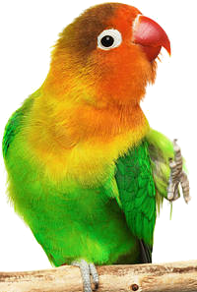

Bird stares into your soul

Bird wants your money

A new challenger approaches!

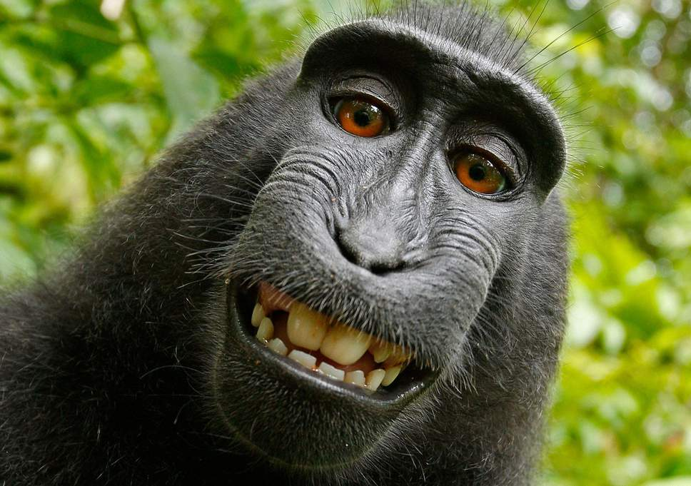

jajaja it is me monkey king of da jungle you will die



a voice is heard from the trees

no guys don’t fight that’s not cool

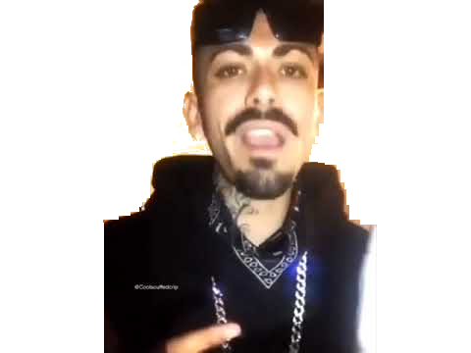You was at the club (Yeah)  
Bottoms up when I first met you (Bottoms up)  
Couldn't get enough (Couldn't get enough)  
Had to get you straight to my bedroom  
Drank still in my cup (My cup)  
Crib is large so you can bring your friends too (Well, bring 'em all)  
Girl, you're full of makeup (Full of makeup)  
She so bad, gon' need her own debut (Yeah)  
Shawty just like me (She like me)  
Loves drugs, hates bein' sober  
In my psychi (She in my head)  
Had my heart and I didn't even know her (I dunno)  
Guess you wouldn't believe (You won't believe it)  
See you in those jeans I wanna pull you closer (Come here)  
Eyes looking Chinese (She Chinese)  
She didn't smoke but now she's a stoner (All day)  
Everything you need (Everything)  
No, no, no mediocre (No mediocre)  
Young, wild and free (She's free)  
No cuffs so no you can't control her (No cuffs)

Body covered in ink (In ink)  
I can beat it up, we can just go slower (Slow it down)  
Baby, come wit me (Wit me)  
Give you everything and it'll never be over (Never ever)  
Girl jus lettin' me know (Lemme know)  
We can go and fuck up some commas (Fuck it up)  
Boyboy West Coast (West Coast)  
Imagine this coming from the bottom (Bottom)  
We just livin' it up (Live it up!)  
Havin' fun, give a fuck what y'all say (Give a fuck)  
Shawty loves to thug (Yeah)  
Matchin' whips as we dippin' down Broadway  
Smoke 'em like a blunt (Spark it up)  
She dab it up, and I be rollin' up all day  
Coffee in my mug (No cup)  
Baby askin' why I lookin' so sloshy  
When we locked eyes (Locked eyes)  
Know you won't mind, didn't have to ask you  
Fuck 'em other guys (Talk)  
Give you everything and we can spit this cash too  
Feelin' like a dream (Like a dream)  
Tell me what you need and I can make that happen (I can do that)  
Like the ocean breeze (Love it)  
All aboard, lemme be your captain (All aboard!)  
Mixed it on repeat  
When the board come on, be like "who's that rappin'?"  
[?], retreat (Make 'em retreat)  
I come from the hood, no, not the Hamptons  
Never wanna leave (Never wanna)  
I give you ecstasy, and a little bit of [?]  
[?] on my sleeve (On my sleeve)  
What you like? I got the latest fashion  
Coolin', watch TV (Chillin')  
Blowing clouds lookin' like a dragon  
All she want is me (Is me)  
And silk sheets, no, no, not satin  
I think you're the one (The one)